*Florida International University*

*School of Computing and Information Sciences*

Software Engineering Focus

Interactive Paint

User Story ID <359>

**Name:**

Jim Louro

**Team Member(s):**

Daniel Mederos

**Project:**

Interactive Paint

**Product Owner(s)**:

Francisco Ortega

**Mentor(s)**:

**Instructor**: Masoud Sadjadi

# User Story Name: Create MultiModal Mode for multiple pen touches

* Description: As a developer, I want to create a mode in the Paint application where we can accept multiple inputs from the user on the same canvas at the same time.

Acceptance Criteria

* The application must read in multiple inputs and treat them all the same way.
* The mode must have the same save and open options as the single painting mode.
* The mode must allow the user to remove all of the designs.
* The mode must allow the user to begin different touch points at the same and at different times without causing a delay or and issue with the painting style.

**Use Case** Create MultiModal Mode for multiple pen touches of the same pen style but a pen for each touch point

|  |  |  |
| --- | --- | --- |
| #**326** | | |
| ***Description*** | When the user selects to enter multimodal mode the paint canvas GUI appears, however this main window uses QT parent child hierarchy with QEvent::TouchBegin:, QEvent::TouchUpdate:, QEvent::TouchEnd: to handle multiple paint brushes at the same time. | |
| ***Actor*** | User of Interactive Paint | |
| ***Precondition*** | GUI must be running | |
| ***Flow of Events*** | **User** | **System** |
| **1.** | User opens MultiModal paint window | A White Paint canvas appears full screen on the display |
| **2.** | User clicks anywhere on the canvas | The point location where the user began touching now creates a black dot that becomes a line when the user moves |
| **3.** | User clicks on the GUI Canvas with multiple fingers and drags them | Multiple lines (one per touch on the canvas) appear as the user moves along the canvas |

**Use Case Diagram**

C:\Users\Jim\AppData\Local\Microsoft\Windows\INetCache\Content.Word\Untitled Diagram.png

\**Sequence Diagram**

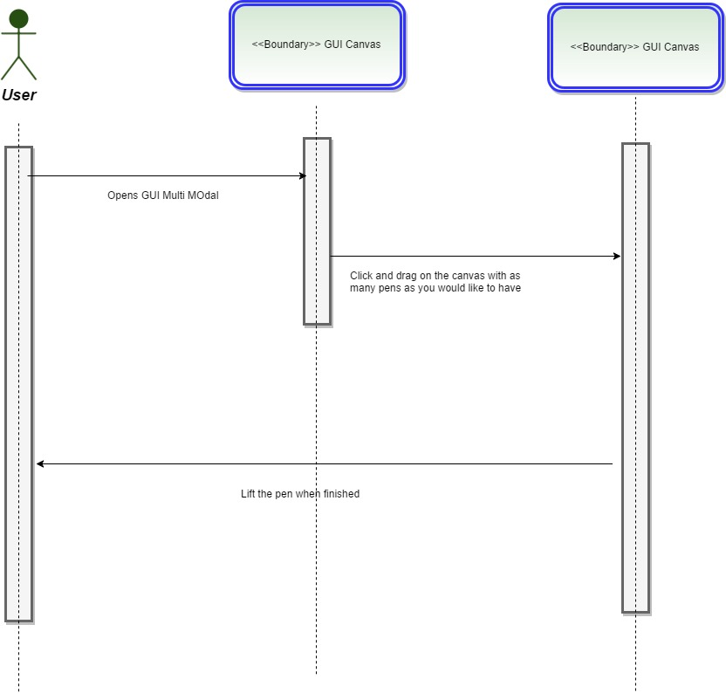

**Class Diagram**

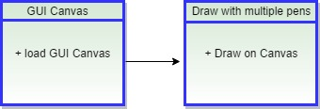

**Integration Test**

**Testing**

**Description:**

* Test the Multiple Pens on the Canvas

**Work Log:**

**Unit Test**

**Test Case 1 (sunny)**

***Purpose:*** Test 1 pen at a time

* Precondition The user must have QT plugin for visual studio and must run the program
* Input: User clicks on the Canvas with 1 input source
* Expected Result: a pen dot then line is made
* Actual Result: Actual result was found to be the expected result.
* Status: **PASSED**

**Test Case 2 (sunny)**

***Purpose:*** Test Multiple pens at once

* Precondition The user must have QT plugin for visual studio and must run the program
* Input: User clicks on the canvas with 3 input sources simultaneously
* Expected Result: 3 dots then 3 lines appear on the canvas
* Actual Result: Actual result was found to be the expected result.
* Status: **PASSED**

**Test Case 3 (rainy)**

***Purpose:*** Test to have 2 pens work simultaneously then add a 3rd pen without removing the first 2 sources

* Precondition The user must have QT plugin for visual studio and must run the program
* Input: User clicks on Canvas with 2 sources and draws then implements a 3rd pen
* Expected Result: First click and draw, makes 2 lines. Then with a 3rd input a 3rd line appears without interrupting the first 2
* Actual Result: Actual result was found to be the expected result.
* Status: **PASSED**

**Screen Shot**

